A
PRACTICAL TRAINING SEMINAR REPORT

ON

“MEASUREMENT OF DIELECTRIC CONSTANT OF CEREALS AT DIFFERENT FREQUENCIES”

SUBMITTED IN PARTIAL FULFILLMENT FOR THE AWARD OF BACHELOR’S DEGREE IN

ELECTRONICS AND COMMUNICATION ENGINEERING
OF
RAJASTHAN TECHNICAL UNIVERSITY

Training at
“INTERNATIONAL CENTRE FOR RADIO SCIENCE (ICRS), JODHPUR”


Submitted To: Submitted by:
Prof. Brijesh Kumar Priya Saini
PTS Coordinator 09EJTEC091
ECE Department ECE, Final Year

JIET SCHOOL OF ENGINEERING & TECHNOLOGY FOR GIRLS
(An Institute of Arun Shanti Education Trust, Jaipur)

ACKNOWLEDGEMENT

I would thankfully acknowledge ICRS, Jodhpur for giving this valuable opportunity to us for study and research work on cereals in the field of our interest. This report is deliberately made by team of students worked on dielectric constant measurement in guidance of Prof. O.P.N. Calla (Director, ICRS). All of his help and support was vital in improving theoretical as well as practical knowledge for us. This report is dedicated to the ICRS and all the reviewers as well as to the instructors in field of microwaves and remote sensing.
I would also grateful to JRF Kishan Gadri, JRF Abhishek Kalla, JRF Rahul Sharma and JRF Gaurav Rathore for their kind and sincere guidelines. We would also like to thank the staff of ICRS for the support provide to us, all the team members for the frank support and lastly to our family members.
Also, thankful to Prof. Sanjay Gaur (Head of Department, ECE JIETSETG), Ms. Upasna Tiwari (Training Placement Officer, JIETSETG Campus) for their guidance for this summer training.

PREFACE
This report is made for the 30 days Summer Training according to Rajasthan Technical University, Kota for 6th semester. It is notice that the summer training of 30 days is included in the syllabi of 6th semester done from any company related to the work of interest which is also, must be well affiliated.
This is the report, submitted to ICRS on the project entitled “Determination of the dielectric constant and moisture content of the cereals such as wheat, rice, moongdal, chana dal, and arhar dal." This report describes the basic concept of dielectric constant.

Dielectric constant is the fundamental parameter of microwave remote sensing. The electrical and physical parameters of material like emissivity, scattering coefficient, polarization and temperature of material, all are depend upon dielectric constant. Dielectric constant is a very useful parameter in the field of microwave remote sensing. Due to this, sensors used in remote sensing can sense the microwave temperature as well as can define the values of scattering coefficient and emissivity of that particular object.

Microwave remote sensing also applicable in field of identification of crop on earth at any location using dielectric constant of that vegetations or objects.
This report is bit part of the project based on Crop Identification application of microwave remote sensing. This will serves in microwave remote sensing for further research on identifying the crop through microwave sensors.

In the Introductory part, we have covered the Basic Concepts of Microwaves and Remote Sensing. It also consists of idea of use of Microwaves in remote sensing.

Chapter 1 comprises of Microwave Components, description and their specifications. It gives full description about every microwave components.

Chapter2 focuses on various microwaves bench experiments with full detail of equipments required. In this chapter all procedures for various microwave bench experiments are also explained, extended with experimental results and observation tables.

Chapter 3 describes the significance of Gunn power supply equipment basically working on the principle of negative differential resistance. It also contains various characteristic graphs on different frequencies of different bands.

Chapter 4 covers the study of the dielectric constant which is the main objective of our project. We broadly selected four frequencies 5.30GHz, 6.60GHz, 10.53GHz and13.00GHz.

Chapter 5 shows all the effects, results and observations of dielectric constant on the basis of moisture content of various samples on different frequencies.

TABLE OF CONTENTS
- INTRODUCTION 6
- COMPANY PROFILE
- About the Organization
- Objectives
- Technical Area
- CHAPTER 0: MICROWAVE AND REMOTE SENSING 7
- Brief about Microwaves 7
- Introduction to Remote sensing 8
- Use of microwaves in Remote Sensing 14
- CHAPTER 1: MICROWAVE COMPONENTS 16
- Microwave Power Supply 16
- Gunn Power Supply 16
- SWR Meter 16
- Frequency Meter 17
- Slotted Line 18
- Attenuators 18
- Tunable Probe Detector 19
- Isolator and circulator 19
- Gunn Oscillator 21
- PIN Modulator 21
- Matched Terminations 21
- Coaxial to Waveguide Adaptors 21
- CHAPTER 2: STUDY OF CHARACTERSTICS OF GUNN OSCILLATOR 23
- Theory 23
- Experimental Procedure 23
- Gunn Oscillator Characteristics graph 24
1). Graph for 5.3 GHz 24
2). Graph for 10.65 GHz 27
3). Graph for 13.00 GHz 34
6. CHAPTER 3: MEASUREMENT FOR CEREALS
- Bench Setup for experiments 39
- Methodology 39
- Preparation of sample 39
- Procedure 40
- Measurement of dielectric constant on various bands 41
- CJ-Band(5.30 GHz) 43
- CJ-Band(6.60 GHz) 44
- X-Band(10.65 GHz) 46
- Ku-Band(13.00 GHz) 47
- CHAPTER4: OVERVIEW 50
- Combinational study of Cereals 50
- Resultant measurements and curves for cereal’s dielectric constant 50
- Variation in moisture content with frequency and dielectric constant 55
- Conclusion 62
CONCLUSION 67
BIBLIOGRAPHY 68
ANNEXURE 69

INTRODUCTION

Any natural material like water, soil, snow and cereals is characterized by two parameters; they are physical and electrical parameters. The electrical parameters are conductivity, permeability and permittivity. The permittivity is further made up of ε’- the storage factor and the ε’’- the loss factor. They are important features that define the behavior of the material.

There are different ways to get values of dielectric constant of the material. Here we are considering cereals. One is to actually measure the dielectric constant of the material in the laboratory. Another way is to use the models and estimate theoretically the dielectric constant on the basis of reflection coefficient, surface conditions and voltage standing wave ratio. These models are frequency dependent, therefore directly applicable.

A dielectric is an electrical insulator that can be polarized by an applied electric field. When an dielectric is placed in an electric field, electric charges do not flow through the material as they do in a conductor but only slightly shift from their average equilibrium positions causing dielectric polarization positive charges are displaced toward the field and negative charges shift in the opposite direction. This creates an internal electric field which reduces the overall field within the dielectric itself.
The study of dielectric properties is concerned with the storage and dissipation of electric and magnetic energy in materials. Mathematically it can be expressed as

Where, ε_{r}= ε’- jε”
ε_{r}=Relative Dielectric Constant
ε’= Storage Factor
ε’’=Loss Factor
By reaction of climate and properties of materials, crops are grown and destroyed. They inherit the organic matter and nutrients from the soil with basic necessities like water and light. Thus, the study of dielectric properties of seeds or cereals such as wheat, rice and dals is important.

The dielectric constant is one of the most significant parameter on which microwave remote sensing of earth material depends. Dielectric constant of any material is defined as the ability of a material to absorb, emit, scatter and reflect apportion of EM wave. It is also known as permittivity of the material. It depends upon the physical properties of material including shape and size of the sample, humidity, temperature, frequency and field of measurement.

COMPANY PROFILE

ABOUT THE ORGANIZATION:
In January 1996 the formation of promoters group started and by June 1997 about 10 promoters signed for starting the International Centre for Radio Science (ICRS) as a registered society. Shri Laxmi Narain Calla Education foundation was the initial promoter and all the funds were being provided for initial work from Shri L.N.C.E. foundation. The ICRS was registered as society on 24th June 1997. The management committee was set up under the Chairmanship of Prof. O.P.N. Calla who earlier in May 1996 was invited by Promoters to become the First Director (Founder Director) of ICRS in the meeting held on 15th May 1996 at New Delhi. An “International Advisory Board was also set up with scientists from various important Laboratories, Research Organizations, Government Organizations and Academics. The management committee has scientists from Indian Research Institutes, Government Departments, Academics and prominent person in their field. After registration on 24th June 1997, ICRS has been engaged in the research activities in many areas. 1. ICRS was registered on 24th June 1997 and having its own office and Laboratory at: "OM-NIWAS" A-23, Shastri Nagar, Jodhpur - 342003 (India). 2. ICRS has committed itself to undertake research activities in radio sciences which was initially started by Sir J C Bose and continue them to keep his memory alive. ICRS has following facilities.
Microwave Laboratory.
Adequate Computer Facility.
Secretarial Facility.
DSP Laboratory.
Infrastructure Facility.

OBJECTIVES:
The object of the International Centre for Radio Science is to conduct research and studies in the field of Radio Science, Telecommunication, Electronics and Information Science and within these fields to promote and organize research with National and International Co-Operation, and the discussion and dissemination of the result of the research.
1. | To encourage the adoption of common methods of measurement, and intercomparison and standardization of measuring instruments used in scientific work.
2. | To create infrastructure commensurate with the need of well-defined programs as accepted and approved by the competent decision making body.
3. | To work in close coordination with concerned National Organization working in the field of radio science.
4. | To upgrade and augment available facilities required for research programs.
5. | To collaborate within National as well as International Institutions and Organizations for hardware and software needs of the Centre and with a view to exchange and share academic resources.
6. | To stimulate and coordinate studies of the scientific aspect and application of telecommunications using guided and ungidued electromagnetic waves.
The scientific aspect of applications in remote sensing using electromagnetic waves, guided and unguided.
The generation and detection of these waves, and the processing of the signals embedded in them.
To study the interaction of radio waves with matter.
To find out the effects of radio waves on the living and nonliving.
Studies, research and development in the area of non-conventional power generation methods.

7. | To conduct short term and long term courses within the framework of the Centre. To have training programs as well as other activities in line of the objectives of the Centre.
8. | To consider and implement at appropriate time, extension of facilities at the Centre in a form which should be suitable for furtherance of the Aims and Objectives of the Centre.
9. | To consider and, if found appropriate by competent body, allow utilization of available facilities to similar other professional bodies at terms and condition as may be decided from time to time by competent authority for causes which are in tune with the overall objectives of the Centre.
10. | To obtain grants, sanctions and take other appropriate steps conventional as well as innovative to make the Centre financially self-supporting.
11. | To purchase and sale the property including land building etc. As per the need and requirement of the institution either on lease, or with patta, or as gift / donation and also to take on rent as approved by competent decision-making body.

TECHNICAL AREA:
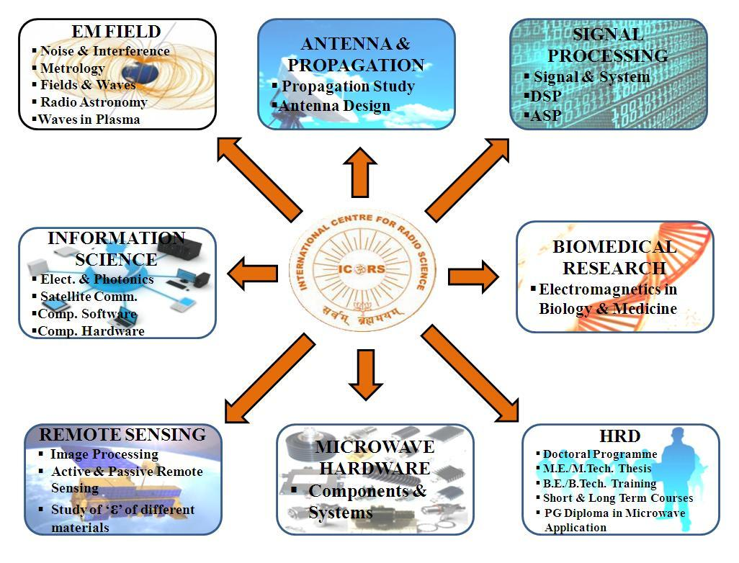
CHAPTER 0
MICROWAVE AND REMOTE SENSING
- BRIEF INTRODUCTION ABOUT MICROWAVES
The term microwaves are generally used for hose wavelengths measured in centimeters, roughly from 30 cm to 1mm (1 to 300 GHz).However, microwave really indicates the wavelength in micron ranges. His means microwave frequencies are up to infrared and visible light regions as described in Radio spectrum. This microwave band designation that derived from World War II radar security considerations has never been officially sanctioned by any industrial, professional or government organization. In August 1969 the United States Department of Defense, Office of Joint Chiefs of Staff, by message of all services, directed the use of a new frequency band breakdown as shown in table 1. The Institute of Electrical and Electronics Engineers (IEEE) recommended new microwave band designation s shown in table 2.
Microwave techniques have been increasingly adopted in such diverse applications as radio astronomy, long distance communications, remote sensing, space navigation, radar systems, and medical equipment and missile electronic systems. As a result of the accelerating rate of growth of microwave technology in research and industry, students who are preparing themselves for, and electronics engineers who are working in, the microwave area faced with the need to understand the theoretical and experimental design and analysis of microwave devices and circuit.

 | Band |  | Frequency range
 | R band |  | 1.70 to 2.60 GHz
 | D band |  | 2.20 to 3.30 GHz
 | S band |  | 2.60 to 3.95 GHz
 | E band |  | 3.30 to 4.90 GHz
 | G band |  | 3.95 to 5.85 GHz
 | F band |  | 4.90 to 7.05 GHz
 | C band |  | 5.85 to 8.20 GHz
 | H band |  | 7.05 to 10.10 GHz
 | X band |  | 8.2 to 12.4 GHz
 | Ku band |  | 12.4 to 18.0 GHz
 | K band |  | 15.0 to 26.5 GHz
 | Ka band |  | 26.5 to 40.0 GHz
 | Q band |  | 33 to 50 GHz
 | U band |  | 40 to 60 GHz
 | V band |  | 50 to 75 GHz
 | W band |  | 75 to 110 GHz
 | Y band |  | 325 to 500 GHz

Table 0.1: Waveguide frequency bands given by Department of Defence
Band | Frequency range |  | Origin of name
HF band | 3 to 30 MHz |  | High Frequency
VHF band | 30 to 300 MHz |  | Very High Frequency
UHF band | 300 to 1000 MHz |  | Ultra High Frequency
L band | 1 to 2 GHz |  | Long wave
S band | 2 to 4 GHz |  | Short wave
C band | 4 to 8 GHz |  | Compromise between S and X
X band | 8 to 12 GHz |  | Used in WW II for fire control, X for cross  (as in crosshair)
K_{u} band | 12 to 18 GHz |  | Kurz-under
K band | 18 to 27 GHz |  | German Kurz (short)
K_{a} band | 27 to 40 GHz |  | Kurz-above
V band | 40 to 75 GHz
W band | 75 to 110 GHz |  | W follows V in the alphabet
mm band | 110 to 300 GHz

Table-0.2 Table of IEEE bands

  - INTRODUCTION TO REMOTE SENSING
Remote sensing is the technology of finding out about the earth from space. It is also developing as the second space technology to become commercially viable after satellite communication. The remote sensing technologies are available for civilian use are almost entirely based upon optical light and infrared radiation , which is slightly longer in wavelength than light perceived by human eye.
The use of microwave for remote sensing is fairly now having been in application only since the early 1960’s, where as aerial photography has been used for over one hundred years and color photography.
Remote Sensing has been identified as a technique with good potential to help the nation’s economic growth and also solves the problems related to it. This includes Wasteland mapping, identifying flood-prone areas, water in catchments areas, assessment of situation of reservoirs, estimating forest area and prediction of crop yield.
The Electromagnetic Spectrum i.e. EM Spectrum provides several applications of remote sensing using microwave sensors accordingly to the frequency of particular band.

THE ELECTROMAGNETIC SPECTRUM
The basic principles of remote sensing with satellites and aircraft are similar to visual observations. Energy in the form of light waves travels from the sun to Earth. Light waves travel similarly to waves traveling across a lake. The distance from the peak of one wave to the peak of the next wave is the wavelength. Energy from sunlight is called the electromagnetic spectrum.

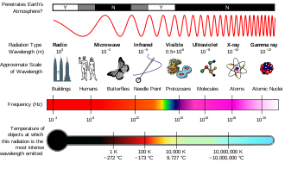Fig 0.1 Electromagnetic spectrum
Wavelengths are measured in micrometers (µm) or nanometers (nm). One um is about .00003937 inch and 1 µm equals 1,000 nm. The visible region of the electromagnetic spectrum is from about 400 nm to about 700 nm. The green color associated with plant vigor has a wavelength that centers near 500 nm (Figure 1).

HOW DOES REMOTE SENSING WORK IN AGRICULTURAL FIELD?
Remote sensing observations have been used for identification and monitoring of agricultural targets since the late 19 century when balloons first started carrying photographic cameras and other instruments over the ground. All optical sensors are limited by solar illumination, cloud cover and haze. In spite of this, optical remote sensing has seen many useful if limited applications in agriculture and other areas. The use of radar sensors for agricultural applications has been intensively studied since 1970. The all weather, day or night data acquisition capability of radar systems, provides a more reliable data source. However, the interaction of the radar signal with agricultural targets is affected by a variety of factors. From this perspective, it is convenient to separate the discussion into radar system parameters which affect radar backscatter - such as frequency, polarization and incidence angle - and target parameters which influence the scattering process.

Target parameters can be related to the dielectric and geometrical properties of the material in question. Dielectric properties are very closely associated with the water content of the material while leaf shape and size (with respect to wavelength) are examples of geometrical characteristics (Brisco & Brown, 1998). The brightness of features in a radar image is dependent on the portion of the transmitted energy that is returned back to the radar (hence the term backscatter) from targets on the surface. The magnitude or intensity of this backscattered energy is dependent on how the radar energy interacts with the surface, which is a function of several variables or parameters. These parameters include the particular characteristics of the radar system and the generated image products as well as the characteristics of the incident surface (land cover type, topography, roughness, etc.).
Frequency or wavelength, incidence angle, and polarization are the primary system parameters which define a radar sensor and its data gathering characteristics. Other important system parameters which influence the type of product to use in an application include range and azimuth resolution, swath width, pulse length, transmitter power, and bandwidth.
There are several types of remote sensing systems used in agriculture but the most common is a passive system that senses the electromagnetic energy reflected from plants. The sun is the most common source of energy for passive systems. Passive system sensors can be mounted on satellites, manned or unmanned aircraft, or directly on farm equipment.
There are several factors to consider when choosing a remote sensing system for a particular application, including spatial resolution, spectral resolution, radiometric resolution, and temporal resolution.
SPATIAL RESOLUTION: refers to the size of the smallest object that can be detected in an image. The basic unit in an image is called a pixel. One-meter spatial resolution means each pixel image represents an area of one square meter. The smaller an area represented by one pixel, the higher the resolution of the image.
SPECTRAL RESOLUTION: refers to the number of bands and the wavelength width of each band. A band is a narrow portion of the electromagnetic spectrum. Shorter wavelength widths can be distinguished in higher spectral resolution images. Multi-spectral imagery can measure several wavelength bands such as visible green or NIR. Land sat, Quick bird and Spot satellites use multi-spectral sensors. Hyper spectral imagery measures energy in narrower and more numerous bands than multi-spectral imagery. The narrow bands of hyper spectral imagery are more sensitive to variations in energy wavelengths and therefore have a greater potential to detect crop stress than multi-spectral imagery. Multi-spectral and hyper spectral imagery are used together to provide a more complete picture of crop conditions.
RADIOMETRIC RESOLUTION: refers to the sensitivity of a remote sensor to variations in the reflectance levels. The higher the radiometric resolution of a remote sensor, the more sensitive it is to detecting small differences in reflectance values. Higher radiometric resolution allows a remote sensor to provide a more precise picture of a specific portion of the electromagnetic spectrum.
TEMPORAL RESOLUTION: refers to how often a remote sensing platform can provide coverage of an area. Geo-stationary satellites can provide continuous sensing while normal orbiting satellites can only provide data each time they pass over an area. Remote sensing taken from cameras mounted on airplanes is often used to provide data for applications requiring more frequent sensing. Cloud cover can interfere with the data from a scheduled remotely sensed data system. Remote sensors located in fields or attached to agricultural equipment can provide the most frequent temporal resolution.

REMOTE SENSING: THE COMPLETE PROCESS
Figure 0.2 illustrates a satellite remote sensing process as applied to agricultural monitoring processes. The sun (A) emits electromagnetic energy (B) to plants (C). A portion of the electromagnetic energy is transmitted through the leaves. The sensor on the satellite detects the reflected energy (D). The data is then transmitted to the ground station (E). The data is analyzed (F) and displayed on field maps (G).

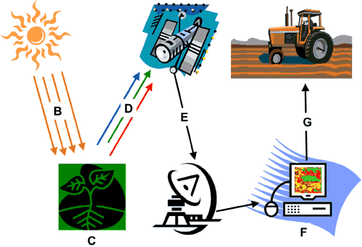

Fig 0.2 the Systems (Multisource) Approach to Remote Sensing
Since the early days of monitoring the Earth by orbiting spacecraft, the development of computer-aided techniques for reliably identifies many categories of surface features within a remotely sensed scene, either by photo interpretation of enhanced images or by classification ranks in itself as an outstanding achievement. Numerous practical uses of such self-contained information are being made without strong dependence on other sources of complementary or supporting data. Thus, automated data processing assists in recognizing and mapping, as an example, major crop types, estimating their yields, and spotting early warning indicators of potential disease or loss of vigor. However, many applications, particularly those involving control of dynamic growth or change systems, or decision making in management of natural resources, or exploration for nonrenewable energy or mineral deposits, require a wide variety of input data of various kinds (from multisource) not intrinsic to acquisition by space borne sensors such as those on Land sat, SPOT, and others of similar purpose.
Some data are essentially fixed or time-independent - slope aspect, rock types, drainage patterns, archaeological sites, etc. - in the normal span of human events. Other data come from measurements or inventories conducted by people on the ground or in the air - weather information, population censuses, traffic flow patterns, soil erodability, etc. However, many vital data are transient or ephemeral - crop growth, flood water extent, insect infestation, limits of snow cover, etc. - and must be collected in a timely sense. Pertinent remote sensing data play a key role in this last instance, and in fact satellite monitoring is often the only practical and cost-effective way to acquire data frequently over large regions.
A given scene imaged at different times of the year can show great variety. Changing Sun angles, atmospheric variations, seasonal differences in vegetation cover, presence of snow, and other variables will produce often pronounced contrasts in the spectral responses that determine "how an image looks". This is evident in this montage of 6 Land sat MSS images of an area in the desert of Utah.
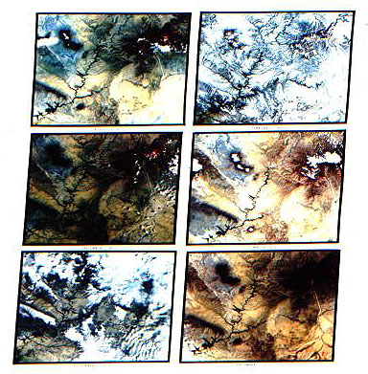
Fig 0.3
One should always keep in mind that remote sensing is an integral part of a larger Information Management System. In fact, in many applications, the user community employs remote sensing inputs as a key component of a continuing cycle of decision making. Consider this diagram:
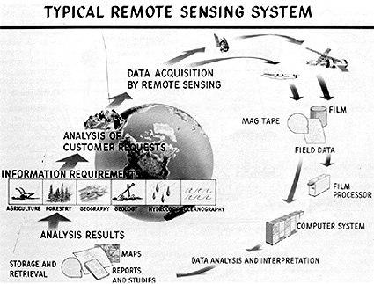
Fig 0.4
This chart shows a simple closed-loop cyclic process, unencumbered by the various feedback loops that no doubt exist. The starting point, and end point as well, is the set of panels labeled Information Requirements. This focuses on the ultimate driver of any information management system: the user and his/her recurring needs. Various disciplines concerned with Earth observations and resources are represented (one not shown is Meteorology). The terrestrial globe in the background reminds us that the system should be worldwide in scope. Information requirements logically lead to user/customer demands. The best remote sensing system approach is the one most responsive to these demands.
There has by now been full realization that the best current and future uses of most Earth-observing data from satellites (or astronauts) stem from correlating and interleaving this type of data with various other types that together are essential inputs to decision making and applications models. This is embodied in the "Multi" concept, but summarized here by these terms: Multistage; Multilevel; Multisensory; Multispectral; Multitemporal; Multisource. Remote sensing data constitute an integral element of a more general Earth Survey Information System, as exemplified here:
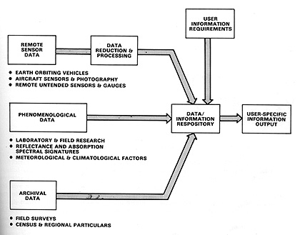
Fig 0.5
The bulk of the data in such systems have in common a geographical significance, that is, they are tied to definite locations on the Earth. In this sense, they are similar to or actually make up what has become a powerful tool in decision making and management: the Geographic Information System (GIS; also known as geobased or geocoded systems). Because vast amounts of spatial or geographically referenced data must be gathered, stored, analyzed in terms of their interrelations, and rapidly retrieved when required for day to day decisions, a GIS that accepts these data must itself be automated (computerized) to be efficiently utilized.
The importance of GIS as a unifying means of handling geospatial data, including often mandatory inputs from remote sensing, warrants an extended explanation of how it works and what is does. This is the subject of Section 15. In Section 1 you will learn how computers with appropriate software are an essential part in processing, manipulating, and integrating data such as is the output of Land sat and other systems. It is safe to say that today, without computers; remote sensing from space would be next to impossible.

  - USE OF MICROWAVES IN REMOTE SENSING
Sensors operating in the microwave region of the Electromagnetic Spectrum are used for remote sensing of regions covered by clouds and for 24 hr data collection. Microwave sensors have advantages and unique abilities over the Optical sensors which are as follows:
- All weather penetration capabilities.
- Day and night capability (independent of illumination of sun).
- Penetration through vegetation and soil to a certain extent.
- Sensitivity to moisture (in liquid or vapor forms).

Difference between Optical sensors and Microwave sensors:
- MW sensors have penetration capability of all weather conditions as well as clouds whereas optical sensors do not give precise results for these applications.
- MW sensors do not depend upon illumination of sun and its angle whereas optical sensors need the illumination to image the target to sense.
- MW sensors can penetrate through vegetation and soil to a limited value whereas optical sensors at low frequency can obtain information about soil and subsoil information.
- MW sensors are sensitive to presence of moisture in target i.e. soil or vegetation whereas optical sensors in visible and infrared defines the molecular resonance properties of surface.

CHAPTER 1
MICROWAVE COMPONENTS
- MICROWAVE POWER SUPPLY
GUNN POWER SUPPLY

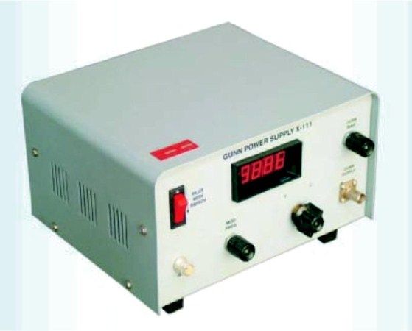
Fig.1.1 Front panel diagram of Gunn Power supply

Model X-111 Gunn Power Supply has been designed to operate high frequency Gunn oscillators and where PIN Modulators are not available; in this supply variable frequency square wave modulation is provided on the bias supply itself.
This consists of a regulated D.C power supply 2.0 to 12.0 V variable and a square wave generator of variable frequency 850 to 1150 Hz.
- SWR METER

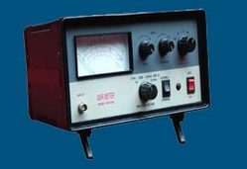
Fig.1.2 Front panel diagram of VSWR Meter
Model - 151 incorporates a number of proprietary features :
- Regulated Beam Supply and Repeller Supply voltages.
- Overload TRIP protection for Beam Supply output.
- LED Digital metering for Beam voltage, current and Repeller voltage.
- Stand-by mode.
- Ultra compact and Reliable.
- Modular construction for easy maintenance

In addition to AM and FM modulation of Beam current, a provision for externally modulating the klystron supply with desired signal waveform has been provided. Model KPS-151 utilizes quality components, rugged construction and ergonomically designed front panel. A careful handling of the instrument will provide years of trouble free service.

1.3 FREQUENCY METER
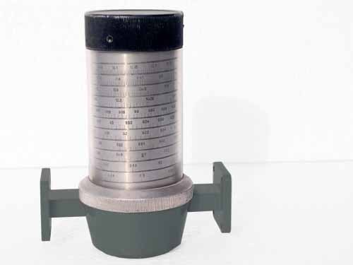
Fig.1.3 Direct Type Frequency Meter
This direct Type Frequency Meter uses a high Q TE11 TUNED CAVITY and a precision piston with the drive mechanism coupled to a micrometer. The meter is of absorption type and designed to give wideband working without ambiguity. Frequency Ran 8.2 to 12.4 GHz, X Band VSWR Better than 1.02 Accuracy + 2MHz Calibration chart provided.

1.4 SLOTTED LINE

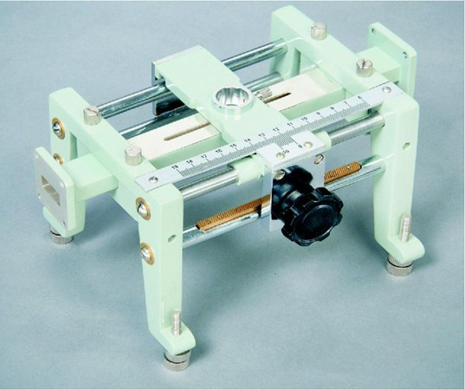
Fig.1.4 Slotted section with precision waveguide slotted line and probe-carriage
Slotted Section consists of a precision waveguide slotted line and the probe carriage. The wavelength slotted line, comprise of an accurately machined section of waveguide in which a small longitudinal slot has been cut which is a basic means for monitoring wave –patterns inside the waveguide system. Such data may be transformed into impedance of the terminal load of unknown system of components, percent of transmitted power, degree of antenna-match and other characteristics of waveguide. A precision built probe carriage has a centimeter-scale with a vernier reading of 0.1mm least count. Frequency range 8.2 to 12.4 GHz Max. Residual VSWR 1.01, Total Vernier travel 15cm typical.

1.5 ATTENUATORS
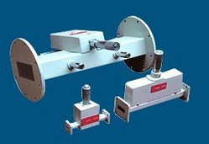 Fig.1.5 Set-Level Type Attenuator
Model 5020 are simple and conveniently variable type set-level attenuators to provide at least 20db of continuously variable attenuation.
These consist of a movable loss vane inside the section of a waveguide by means of a micrometer. The configuration of lossy-vane is so designed to obtain the low VSWR characteristics over the entire frequency band.
These are meant for adjusting power levels and isolating a source and load etc.

1.6 TUNABLE PROBE AND DETECTOR

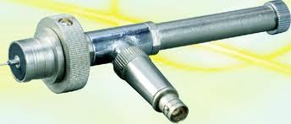
Fig.1.6 Tunable Probe and Detector
Tunable probe is designed to be used with slotted line section. These are meant for exploring the energy of Electric Field in a suitably fabricated section of waveguide. The depth of penetration into a waveguide section is adjustable by the knob of the probe. The tip picks up the RF power from the line; this power is rectified by crystal detector having diode IN21/23 which is fed to the VSWR meter or indicating instruments.

1.7 ISOLATOR AND CIRCULATOR
A circulator is a ferrite device (ferrite is a class of materials with strange magnetic properties) with usually three ports. The beautiful thing about circulators is that they are non-reciprocal. That is, energy into port 1 predominantly exits port 2, energy into port 2 exits port 3, and energy into port 3 exits port 1. In a reciprocal device the same fraction of energy that flows from port 1 to port 2 would occur to energy flowing the opposite direction, from port 2 to port 1.
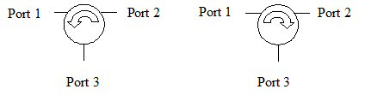
Fig.1.7 CCW and CW circulators
The selection of ports is arbitrary, and circulators can be made to "circulate" either clockwise (CW) or counterclockwise (CCW) In addition to the ferrite substrate, a magnet is required to make a circulator. Circulators come in waveguide, coax, and "drop-in" micro strip varieties. Micro strip circulators are often used in T/R modules to duplex the antenna to the power amp and LNA. Waveguide always provides the best loss and power handling. Here's a WR-42 (Ku-band) waveguide circulator we found on Ebay:

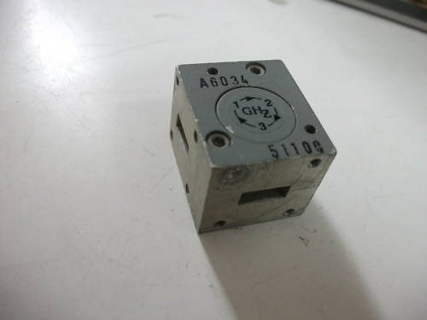
Fig.1.8 WR42 waveguide circulator
A circulator is sometimes called a "duplexer", meaning that is duplexes two signals into one channel (e.g. transmit and receive into an antenna). This is not to be confused with the term "diplexer" which is refers to a filter arrangement where two frequency bands are separated into two channels from a single three-terminal device. A lot of people mix up these terms. You can remember the correct definitions because "filter" and "diplexer" both have an "i" in them, and "circulator" and "duplexer" both has “u".
What are circulators good for? The make a great antenna interface for a transmit/receive system. Energy can be made to flow from the transmitter (port 1) to the antenna (port 2) during transmit, and from the antenna (port 2) to the receiver (port 3) during receive. Circulators have low electrical losses and can be made to handle huge powers, well into kilowatts. They usually operate over no more than an octave bandwidth, and are purely an RF component (they don't work at DC).
1.8 GUNN OSCILLATOR
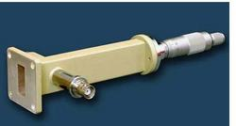

Fig.1.9 Gunn Oscillator
Gunn Oscillators are used to generate the microwave signal and its Micrometer is used to tune the output frequency of Gunn oscillator. We are manufacturing Gunn Oscillator from 4 GHz to 110Ghz. Gunn oscillators provide a highly reliable source for generating the low power microwave signal.
1.9 PIN MODULATOR

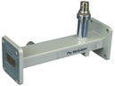 Fig.1.10 PIN Modulator
Through wide range of frequencies. These modulators utilize PIN diode which are mounted across the waveguide line with a R.F. isolated DC bias lead passing to an external TNC (F) connectors
1.10 MATCHED TERMINATION

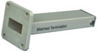

Fig.1.11 Matched Termination

Matched terminations are used to terminate the waveguide transmission line operating at low average power. The loads are carefully designed to absorb all the applied power and VSWR of matched termination is low. These are used in the measurement of reflection coefficient and where the matched load is required.
1.11 COAXIAL TO WAVEGUIDE ADAPTORS (TRANSITION)
Model 7061, 7063 Adapters consists of a section of waveguide flanged on one end terminated with a smooth polished flat on the other hand. These adapters works as a loss less transition from rectangular waveguide to coaxial line or vice-versa. These are available with N (M) type or SMA (M) connectors so that a low VSWR can be achieved over entire frequency band.
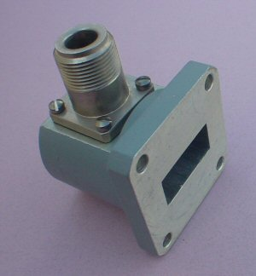
Fig.1.12 Waveguide to coaxial (WR-62 to type N)
CHAPTER 2
STUDY OF CHARACTERSTICS OF GUNN OSCILLATOR
- THEORY:
The Gunn diode oscillator normally consist of a resonant cavity, an arrangement for coupling diode to the cavity a circuit for biasing the diode and a mechanism to couple the RF power from cavity to external circuit load. A co-axial cavity or a rectangular wave guide cavity is commonly used.
The circuit using co-axial cavity has the Gunn diode at one end at one end of cavity along with the central conductor of the co-axial line. The output is taken using an inductively or capacitive coupled probe. The length of the cavity determines the frequency of oscillation. The location of the coupling loop or probe within the resonator determines the load impedance presented to the Gunn diode. Heat sink conducts away the heat due to power dissipation of the device.

2.2 EXPERIMENTAL PROCEDURE

- Set the components and equipments as shown in Figure.
- Initially set the variable attenuator for minimum attenuation.
- Keep the control knobs of Gunn power supply as below
Meter switch _“OFF”
Gunn bias knob– Fully anti clockwise
PIN bias knob_ Fully anticlockwise
PIN mode frequency– any position
Switch no. 4 _ INT
- Keep the control knob of VSWR meter as below:
Meter Switch _ Normal
Input Switch _ Low Impedance
Range dB Switch _ 40 Db
Gain control Knob _ Fully Clockwise

- Set the micrometer of Gunn oscillator for required frequency of operation.
- Switch “ON” the Gunn power supply.
- Measure the Gunn diode current to corresponding to the various Gunn bias voltages through the digital panel meter and meter switch.
- Do not exceed the bias voltage above 10 volts.
- Plot the voltage and current readings on the graph.
- Measure the threshold voltage which corresponding to max current.

Note: Do not keep Gunn bias knob position at threshold position for more than 10-15 sec.readings should be obtained as fast as possible. Otherwise due to excessive heating Gunn diode may burn.

2.3 GUNN OSCILLATOR CHARACTERISTICS GRAPH

- GRAPH FOR 5.3GHZ

s.no. | Frequency | Power | s.no. | Frequency | Power
1. | 8.21 | 2.4 | 14. | 8.27 | 1.714
2. | 8.22 | 0.65 | 15. | 8.26 | 1.06
3. | 8.22 | 0.18 | 16. | 8.29 | 1.05
4. | 8.23 | 0.035 | 17. | 8.29 | 2.24
5. | 8.23 | 0.034 | 18. | 8.28 | 2.72
6. | 8.24 | 0.024 | 19. | 8.28 | 2.63
7. | 8.24 | 0.54 | 20. | 8.29 | 2.12
8. | 8.24 | 2.127 | 21. | 8.29 | 2.02
9. | 8.24 | 1.074 | 22. | 8.32 | 2.34
10. | 8.26 | 2.44 | 23. | 8.36 | 1.96
11. | 8.27 | 2.06 | 24. | 8.38 | 1.3
12. | 8.27 | 1.76 | 25. | 8.38 | 1.83
13. | 8.26 | 2.86 | 26. | 8.38 | 1.92

Table -2.

Fig-2(a)

s.no. | voltage | current | s.no. | voltage | current
1. | 0.5 | 0.05 | 13. | 6.52 | 0.56
2. | 1 | 0.1 | 14. | 7.02 | 0.57
3. | 1.5 | 0.14 | 15. | 7.5 | 0.58
4. | 2 | 0.19 | 16. | 8.01 | 0.59
5. | 2.5 | 0.24 | 17. | 8.5 | 0.57
6. | 3 | 0.29 | 18. | 9.05 | 0.53
7. | 3.5 | 0.34 | 19. | 9.5 | 0.52
8. | 4 | 0.38 | 20. | 10.01 | 0.51
9. | 4.52 | 0.43 | 21. | 10.5 | 0.5
10. | 5.01 | 0.46 | 22. | 11 | 0.49
11. | 5.5 | 0.5 | 23. | 11.56 | 0.48
12. | 6 | 0.53

Table -2.2

Fig-2(b)

s.no. | Micrometer Reading | Frequency | s.no. | Micrometer Reading | Frequency
1. | 22.05 | 4.66 | 8. | 19.03 | 4.98
2. | 22.19 | 4.71 | 9. | 18.14 | 5.03
3. | 22.16 | 4.75 | 10. | 16.07 | 5.16
4. | 21.17 | 4.8 | 11. | 16.24 | 5.21
5. | 21.33 | 4.84 | 12. | 16.38 | 5.25
6. | 20.48 | 4.9 | 13. | 15.07 | 5.3
7. | 19.16 | 4.93 | 14. | 14.09 | 5.34

Table -2.3
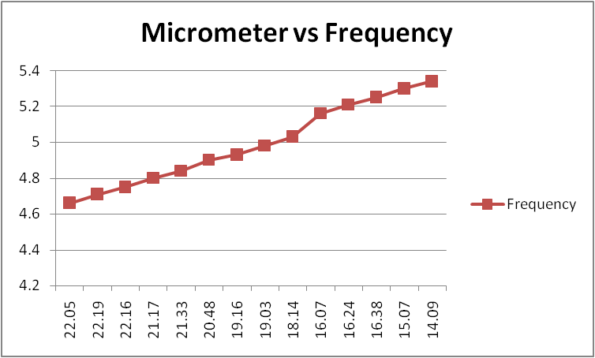

Fig-2(c)
s.no. | Micrometer reading | Power | s.no. | Micrometer reading | Power
1. | 22.05 | 8.82 | 8. | 19.03 | 5.469
2. | 22.19 | 5.105 | 9. | 18.14 | 4.634
3. | 22.16 | 0.603 | 10. | 16.07 | 6.129
4. | 21.17 | 2.345 | 11. | 16.24 | 5.027
5. | 21.33 | 1.399 | 12. | 16.38 | 1.416
6. | 20.48 | 4.898 | 13. | 15.07 | 5.266
7. | 19.16 | 5.204 | 14. | 14.09 | 5.431

Table -2

Fig-2(d)
s.no. | Voltage | Frequency | s.no. | Voltage | Frequency
1. | 8.21 | 4.67 | 14. | 8.27 | 5.3
2. | 8.22 | 4.72 | 15. | 8.26 | 5.56
3. | 8.22 | 4.76 | 16. | 8.29 | 5.59
4. | 8.23 | 4.81 | 17. | 8.29 | 5.62
5. | 8.23 | 4.86 | 18. | 8.28 | 5.67
6. | 8.24 | 4.9 | 19. | 8.29 | 5.7
7. | 8.24 | 4.95 | 20. | 8.29 | 5.73
8. | 8.24 | 5 | 21. | 8.32 | 5.75
9. | 8.24 | 5.04 | 22. | 8.36 | 5.78
10. | 8.26 | 5.13 | 23. | 8.38 | 5.81
11. | 8.27 | 5.18 | 24. | 8.38 | 5.83
12. | 8.27 | 5.23 | 25. | 8.38 | 5.94
13. | 8.26 | 5.27 | 26. | 8.38 | 6.02

Table -2.5

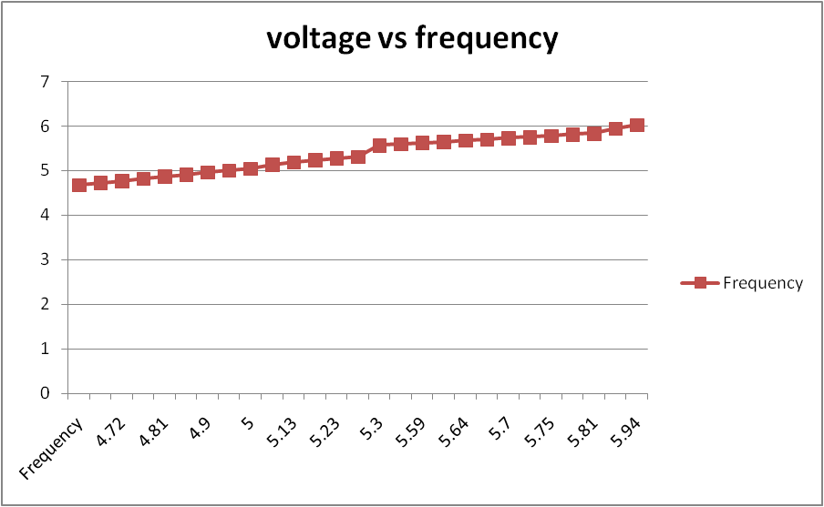
Fig-2(e)

s.no. | Voltage | Power | s.no. | Voltage | Power | s.no. | Voltage | Power
1. | 8.21 | 2.4 | 10. | 8.26 | 2.44 | 19. | 8.28 | 2.63
2. | 8.22 | 0.65 | 11. | 8.27 | 2.06 | 20. | 8.29 | 2.12
3. | 8.22 | 0.18 | 12. | 8.27 | 1.76 | 21. | 8.29 | 2.02
4. | 8.23 | 0.035 | 13. | 8.26 | 2.86 | 22. | 8.32 | 2.34
5. | 8.23 | 0.034 | 14. | 8.27 | 1.714 | 23. | 8.36 | 1.96
6. | 8.24 | 0.024 | 15. | 8.26 | 1.06 | 24. | 8.38 | 1.3
7. | 8.24 | 0.54 | 16. | 8.29 | 1.05 | 25. | 8.38 | 1.83
8. | 8.24 | 2.127 | 17. | 8.29 | 2.24 | 26. | 8.38 | 1.92
9. | 8.24 | 1.074 | 18. | 8.28 | 2.72

Table -2.6

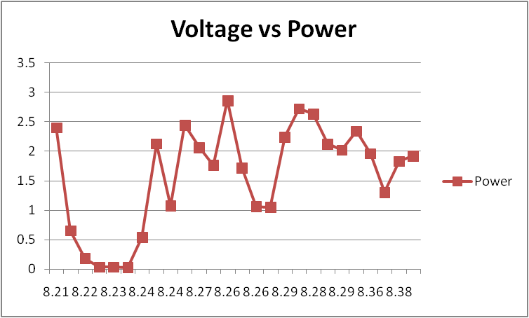
Fig-2(f)

- Graph for 10.65GHz
s.no. | Frequency | Power | s.no. | Frequency | Power | s.no. | Frequency | Power
1. | 8.21 | 0.0006 | 8. | 10.51 | 1.1326 | 15. | 12.3 | 0.9484
2. | 8.69 | 0.0792 | 9. | 11.02 | 0.151 | 16. | 12.57 | 1.5754
3. | 8.99 | 0.8027 | 10. | 11.179 | 2.8668 | 17. | 13.105 | 0.8369
4. | 9.13 | 0.5807 | 11. | 11.25 | 2.6448
5. | 9.51 | 1.1694 | 12. | 11.51 | 1.8251
6. | 9.55 | 2.3334 | 13. | 11.92 | 1.2393
7. | 10.01 | 2.9234 | 14. | 12.01 | 1.2764
Table -2.7

Fig-2(g)
s.no. | Voltage | Frequency | s.no. | Voltage | Frequency
1. | 6.56 | 8.21 | 10. | 11.1 | 11.179
2. | 7.28 | 8.69 | 11. | 11.1 | 11.25
3. | 9.74 | 8.99 | 12. | 11.1 | 11.51
4. | 10.22 | 9.13 | 13. | 11.1 | 11.92
5. | 10.23 | 9.51 | 14. | 11.1 | 12.01
6. | 10.38 | 9.55 | 15. | 11.11 | 12.3
7. | 10.56 | 10.01 | 16. | 11.11 | 12.57
8. | 10.58 | 10.51 | 17. | 11.1 | 13.105
9. | 11.1 | 11.02

Table -2.8

Fig-2(h)
s.no. | Voltage | Current | s.no. | Voltage | Current
1. | 0.51 | 0.05 | 12. | 6 | 0.44
2. | 1 | 0.1 | 13. | 6.5 | 0.42
3. | 1.52 | 0.15 | 14. | 7 | 0.41
4. | 2 | 0.21 | 15. | 7.52 | 0.41
5. | 2.52 | 0.26 | 16. | 8.04 | 0.4
6. | 3 | 0.31 | 17. | 8.56 | 0.4
7. | 3.5 | 0.35 | 18. | 9.06 | 0.4
8. | 4 | 0.4 | 19. | 9.52 | 0.39
9. | 4.52 | 0.42 | 20. | 10.04 | 0.38
10. | 5 | 0.45 | 21. | 10.56 | 0.38
11. | 5.52 | 0.45 | 22. | 11.07 | 0.38

Table -2.9

Fig-2(i)

s.no. | Micrometer Reading | Frequency | s.no. | Micrometer Reading | Frequency
1. | 19.23 | 8.51 | 10. | 8.34 | 10.5
2. | 18.31 | 8.67 | 11. | 7.49 | 11
3. | 17.13 | 8.78 | 12. | 6.12 | 11.25
4. | 15.14 | 9.05 | 13. | 5.49 | 11.5
5. | 14.76 | 9.115 | 14. | 5.25 | 12
6. | 14.16 | 9.23 | 15. | 4.06 | 12.25
7. | 12.57 | 9.5 | 16. | 3.4 | 12.5
8. | 10.24 | 10 | 17. | 2.39 | 13
9. | 9.41 | 10.25 | 18. | 2.38 | 13.23

Table -2.10

Fig-2(j)
s.no. | Power | Micrometer Reading | s.no. | Power | Micrometer Reading
1. | 0.41 | 24 | 13. | 3.13 | 10.27
2. | 0.00000261 | 23.31 | 14. | 3.27 | 9.11
3. | 0.0000016 | 20.37 | 15. | 3.22 | 9.43
4. | 0.0102 | 19.47 | 16. | 2.78 | 8.38
5. | 1.366 | 19.27 | 17. | 2.46 | 7.44
6. | 1.416 | 19.16 | 18. | 3.53 | 6.14
7. | 2.841 | 18.09 | 19. | 1.77 | 4.08
8. | 3.24 | 17.16 | 20. | 1.23 | 4.48
9. | 1.57 | 17.05 | 21. | 1.47 | 4.26
10. | 1.4 | 16.23 | 22. | 1.72 | 3.44
11. | 1.386 | 15.24 | 23. | 1.8 | 2.39
12. | 2.39 | 12.1 | 24.

Table -2.11

Fig-2(k)

s.no. | Voltage | Power | s.no. | Voltage | Power
1. | 6.56 | 0.0006 | 10. | 11.1 | 2.8668
2. | 7.28 | 0.0792 | 11. | 11.1 | 2.6448
3. | 9.74 | 0.8027 | 12. | 11.1 | 1.8251
4. | 10.22 | 0.5807 | 13. | 11.1 | 1.2393
5. | 10.23 | 1.1694 | 14. | 11.1 | 1.2764
6. | 10.38 | 2.3334 | 15. | 11.11 | 0.9484
7. | 10.56 | 2.9234 | 16. | 11.11 | 1.5754
8. | 10.58 | 1.1326 | 17. | 11.1 | 0.8369
9. | 11.1 | 0.151
Table -2.1

Fig-2(l)

- Graph for 13.00GHz
s.no. | Frequency | Power
1. | 13.03 | 0.19
2. | 13.02 | 0.94
3. | 13.01 | 1.52
4. | 13 | 1.38
5. | 12.99 | 1.24
6. | 12.98 | 0.59

Table -2.13
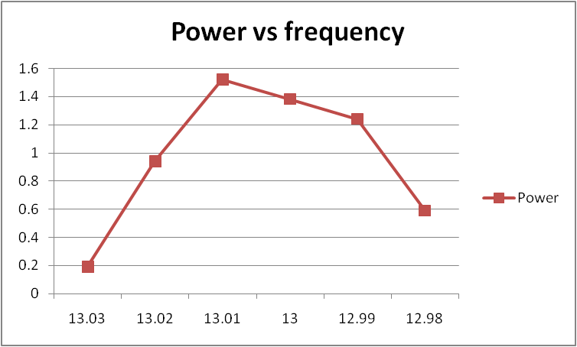
Fig-2(m)
s.no. | Micrometer | Frequency
1. | 11 | 12.92
2. | 11.27 | 12.98
3. | 11.23 | 13
4. | 11.21 | 13.01
5. | 11.19 | 13.02
6. | 11.16 | 13.03
7. | 11.12 | 13.04
8. | 11.1 | 13.05
9. | 11.38 | 13.1
10. | 10.16 | 13.2
11. | 10.7 | 13.23
12. | 10.37 | 13.28

Table -2.14

Fig-2(n)
s.no. | Micrometer | Power
1. | 11 | 0.98
2. | 11.27 | 1.08
3. | 11.23 | 1.02
4. | 11.21 | 1.05
5. | 11.19 | 1.04
6. | 11.16 | 1.07
7. | 11.12 | 0.93
8. | 11.1 | 1.1
9. | 11.38 | 1.8
10. | 10.16 | 1.05
11. | 10.7 | 1.39
12. | 10.37 | 1.37

Table -2.1

Fig-2(o)
s.no. | Voltage | Current | s.no. | Voltage | Current
1. | 1 | 0.22 | 12. | 6.5 | 0.5
2. | 1.5 | 0.34 | 13. | 7 | 0.49
3. | 2 | 0.42 | 14. | 7.5 | 0.48
4. | 2.5 | 0.49 | 15. | 8 | 0.48
5. | 3 | 0.54 | 16. | 8.5 | 0.47
6. | 3.5 | 0.57 | 17. | 9 | 0.47
7. | 4 | 0.56 | 18. | 9.5 | 0.47
8. | 4.5 | 0.53 | 19. | 10 | 0.46
9. | 5 | 0.52 | 20. | 10.5 | 0.46
10. | 5.5 | 0.51 | 21. | 11 | 0.46
11. | 6 | 0.5 | 22. | 11.5 | 0.46

Table -2.16
Fig-2(p)
s.no. | Voltage | Frequency
1. | 4.5 | 13.03
2. | 6.5 | 13.02
3. | 9.5 | 13.01
4. | 10.6 | 13
5. | 10.8 | 12.99
6. | 11.4 | 12.98

Table -2.17

Fig-2(q)

s.no. | Voltage | Power
1. | 4.5 | 0.19
2. | 6.5 | 0.94
3. | 9.5 | 1.52
4. | 10.6 | 1.38
5. | 10.8 | 1.24
6. | 11.4 | 0.59

Table -2.18

Fig-2(r)

CHAPTER 3
MEASUREMENT FOR CEREALS

3.1BENCH SETUP FOR EXPERIMENT:
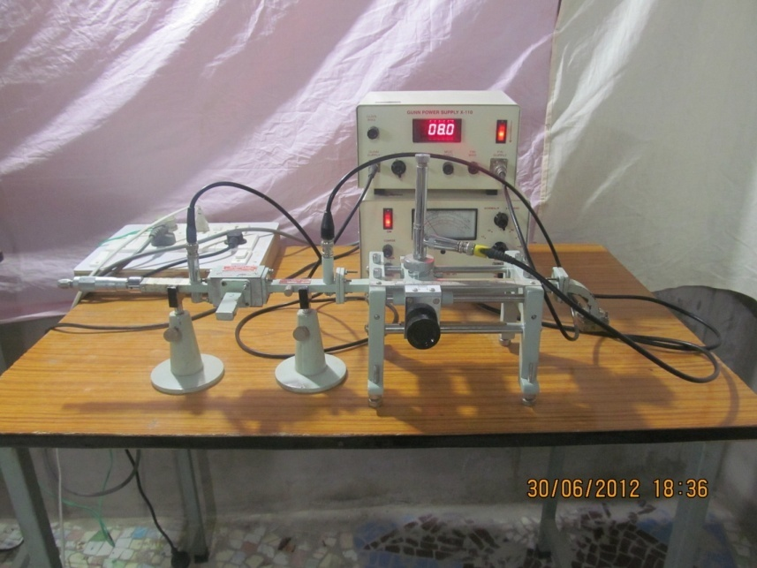
Fig 3.1 Bench setup for measuring Dielectric constant
3.2 METHODOLOGY:
- Dielectric Constant:- In lossy materials, the conductivity is zero, i.e. the material is a poor conductor of electricity and the material is called dielectric material. The dielectric constant can be defined as the extent to which the substance concentrates the electrostatic lines of flux. It specifies the relative permittivity of a material. It specifies the relative permittivity of a material. Relative permittivity is the permittivity of the material with respect to free space.

(Relative permittivity (ε_{r}) =permittivity of material (ε)/permittivity of free space (ε_{o})
An important property of dielectric is its ability to support an electrostatic field while dissipating minimal energy in the form of heat.

3.3 PREPARATION OF SAMPLE:
- Preliminary sample-
- Firstly weighted the empty cell.
- Then after take natural sample of each and weighed them before taking measurements.
- Oven dried sample-
- The samples were firstly oven dried at 110˚C for about 30 minutes.
- Equal amount of oven dried samples were taken for measurements.
- Take weight of each sample after oven dried process.
- Saturated sample-
- The measured quantity of water was added to the samples using dropper.
- Take weight of each sample after saturation.
- The samples were kept for 24 hours for homogeneous mixing and final settlement.
- The dielectric constant of the samples was then measured at different gravimetric moisture at successive time intervals.
- Weighted each sample also at different gravimetric moisture at successive time intervals.

3.4 Procedure:
EQUIPMENT REQUIRED:
1. Gunn power supply 5kps – 610
2. Gunn oscillator
3. Isolator XI-621
4. Frequency meter XF-710
5. Variable attenuator XA-520
6. Slotted section XS-651
7. Tunable probe XP-655
8. VSWR meter SW-115
9. Wave guide stand XU-535
10. Movable Short XT-481
11. Short circuit termination XL-400

THEORY: The electromagnetic field at any point of transmission line may be considered as the sum of two travelling waves: the “incident wave” propagates from generator and the reflected wave propagates towards the generator.
The magnitude and phase of reflected wave depends upon amplitude and phase of the reflected impedance. The superimposition of two travelling waves, gives rise to standing wave along the line. The maximum field strength is found where two waves are in phase and minimum where the two waves are in opposite phase. The distance between two successive minima (or maxima) is half the guide wavelength on the line. The ratio of electric field strength of reflected and incident wave is called reflection coefficient.
The voltage standing wave ratio is defined as the ratio between maximum and minimum field strength along the line.
S = Emax / Emin
S = │E_{i}│+│Er│/│Ei│-│Er│
Where,
Ei = incident voltage
Er = reflected voltage

PROCEDURE:
- Set up the components and equipments as shown in figure
- Set the variable attenuator at maximum position.
- Keep the control knobs of VSWR meter as below:
  - Range dB - 50 dB position
  - Input switch - low impedance
  - Meter switch - normal position
  - Gain (coarse and fine) - full clockwise
- Keep the control knob of the power supply as under:
  - Meter switch - (V)
  - Gunn bias knob - full anti clockwise
  - Pin bias knob - full anti clockwise
  - Switch no. 4 - INT position
  - Pin mod frequency - any position
- Set the micrometer of Gunn oscillator for required frequency of operation.
- Connect the cord of cooling fan to the socket provided at the back of Gunn power supply.
- Switch on the Gunn power supply and VSWR meter.
- Increase the Gunn bias control knob on 10V maximum position.
- Rotate pin bias knob to around maximum position.
- Tune the maximum output in the VSWR meter through frequency control knob of modulation and tunable probe.
- If necessary change the range dB switch of VSWR meter to higher or lower dB position.

MEASUREMENT OF HIGH VSWR (double minimum method):
- Set the depth of SS tuner slightly more for maximum VSWR.
- Move the probe along with slotted line until a minimum is indicated.
- Adjust the VSWR meter gain control knob and variable attenuator to obtain the reading of 3dB of normal dB scale (0 to 10 dB) of VSWR meter (minima position set the 3dB position).
- Move the probe to the left on slotted line until full scale deflection is obtained i.e. ‘0’dB on 0-10 dB scale. Note and record the probe position on slotted line. Let it be d1.
- Repeat the step 3 and 4 then move the probe right along with slotted line until full scale deflection is obtained on 0-10 dB scale. Let it be d2.
- Replace the SS tuner and termination by movable short.
- Measure the distance between two successive minima position of probe. Twice this distance is guide wavelength λ_{g.}
- Calculate SWR by following equation;
VSWR = $\frac{λg}{π(d1-d2)}$
3.5 MEASUREMENT OF DIELECTRIC CONSTANT ON VARIOUS BANDS
S.NO | BANDS | FREQUENCIES
1.) | CJ-BAND | 5.30 GHz ,6.60GHz
2.) | X-BAND | 10.65 GHz
3.) | Ku-BAND | 13.00 GHz
Table-3.1 Different frequency for selected bands
The relevant equations used for determining the dielectric constant in the given frequencies are as follows:-

k=2Π/λ_{g} (2)
where,
k= Propagation constant
λg = Guide wavelength
φ= 2k (D-Dr-lε) (3)
Where,
φ = Phase angle
D = First voltage minima of sample
Dr = First voltage minima when waveguide is short circuited
l_{ε}= length of sample

S. NO. | BANDS | LENGTH OF THE SAMPLE(cm)
1. | CJ-BAND | 0.694
2. | X-BAND | 0.568
3. | Ku-BAND | 0.476
Table-3.2 Length of broader side of waveguide for different frequency bands

|Г| =(r-1)/(r+1) (4)
Where, |Г| =reflection coefficient
r =voltage standing wave ratio (VSWR)

COMPLEX TRANSCENDENTAL EQUATIONS:-

K= (-2|Г|sinφ)/ (kl_{ε} (1+|Г|²+2|Г|cosφ)) (5)
A= (|Г|²-1)/(k l_{ε}(1+|Г|²+2|Г|cosφ)) (6)
Now, solve for X in the real transcendental equation, using the two sets of data to determine X’
R= (A X’²) / (tan X’- X’ (1+tan² X’)) (7)
K’ = (R tan h R (1+tan² X’) + X’ tan X’ (1- tan h²R))/
((R²+X’²) (1+ tan² R tan² X’)) (8)
If K and K’ are almost identical, the values of X’ and R calculated are acceptable; if not, this method of solution does not apply.

T= (R²+X’²)^{1/2} (9)
$τ=\tan^{-1}{(X^{'}/R)}$ 45˚<𝝉< 90˚ (10)
γ_{e =} (T/k l_{e}) ² <(2*(𝝉-90˚) ) (11)
γ_{e =} G_{e}- jB_{e} (12)
Where,
γe = admittance
G_{e =}conductance
B_{e =} susceptance

ε’= (G_{e}+ (λ_{g}/2a)²)/(1+(λ_{g}/2a)²) (13)
ε’’= (-B_{e})/(1+(λ_{g}/2a)²) (14)
ε_{r =} ε’-jε’’ (15)
Where,
ε’ =storage factor
ε’’=loss factor
ε_{r =}dielectric constant

3.6 CJ-BAND (5.30GHZ):-

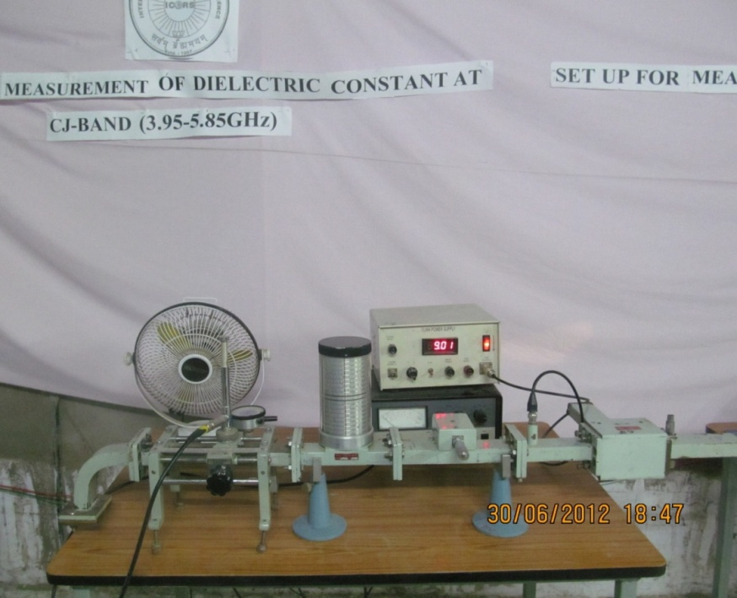
Fig. 3.2 Bench setup for measuring dielectric constant at 5.30 GHz
For frequency 5.30 GHz measurements taken for different forms of cereals are given as follows-

SAMPLES | DIELECTRIC CONSTANT | LOSS FACTOR
PRELIMANARY
Wheat | 9.0370 | 0.5077
Rice | 8.7754 | 1.0614
Arhar | 8.6727 | 0.0591
Chana | 8.4098 | 0.846
Moong | 8.8048 | 1.2907
OVEN DRIED
Wheat | 8.8458 | 0.8423
Rice | 8.2015 | 0.2351
Arhar | 8.1903 | 1.5508
Chana | 8.0805 | 1.6259
Moong | 8.4429 | 0.5021
SATURATED
Wheat | 11.0423 | 3.9736
Rice | 11.0012 | 3.2430
Arhar | 10.8084 | 2.3152
Chana | 11.2015 | 3.5625
Moong | 10.7458 | 2.6927

Table 3.3 Tabulated form of Dielectric constants of cereals for CJ band
3.7 CJ-BAND (6.60GHZ):-

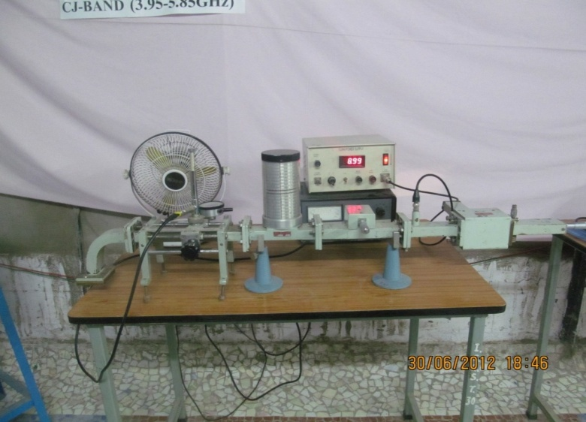
Fig. 3.3 Bench setup for measuring dielectric constant at 6.60 GHz

For frequency 6.60 GHz measurements taken for different forms of cereals are given as follows-

SAMPLES | DIELECTRIC CONSTANT | LOSS FACTOR
PRELIMINARY
Wheat | 8.8451 | 0.4132
Rice | 8.5023 | 0.6594
Arhar | 8.4805 | 1.2361
Chana | 8.2315 | 0.1625
Moong | 8.5509 | 1.2365
OVEN DRIED
Wheat | 8.6450 | 0.1527
Rice | 8.0509 | 1.6718
Arhar | 8.0010 | 0.9827
Chana | 7.9998 | 1.1560
Moong | 8.0521 | 0.2376
SATURATED
Wheat | 10.8264 | 3.7927
Rice | 10.7765 | 3.1592
Arhar | 10.2128 | 2.6051
Chana | 11.0519 | 3.0519
Moong | 10.5023 | 2.0010

Table 3.4 Tabulated form of Dielectric constants of cereals for CJ band

3.8 X-BAND (10.65GHZ):-

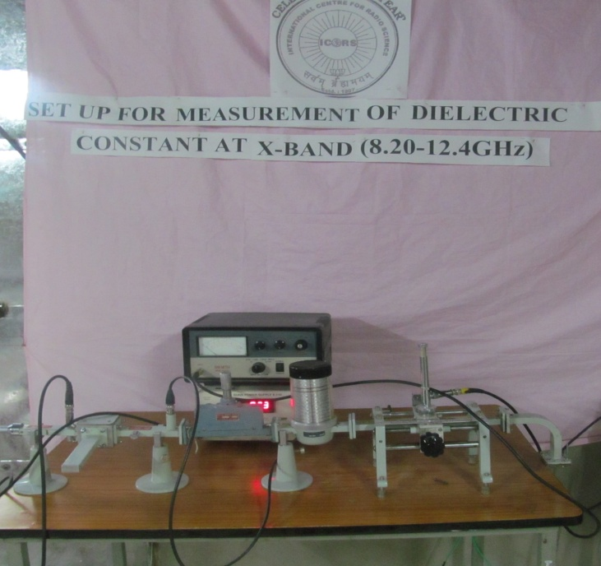
Fig. 3.4 Bench setup for measuring dielectric constant at 10.65 GHz
For frequency 10.65 GHz measurements taken for different forms of cereals are given as follows-

SAMPLES | DIELECTRIC CONSTANT | LOSS FACTOR
PRELIMINARY
Wheat | 6.6645 | 1.9533
Rice | 6.6402 | 1.9600
Arhar | 6.8166 | 1.9997
Chana | 6.4729 | 1.7403
Moong | 6.3555 | 1.9389
OVEN DRIED
Wheat | 6.2392 | 0.7156
Rice | 6.0010 | 0.1724
Arhar | 6.5158 | 0.7860
Chana | 6.0264 | 1.0644
Moong | 6.0853 | 1.1755
SATURATED
Wheat | 8.5066 | 2.0152
Rice | 8.2617 | 1.9573
Arhar | 7.2047 | 1.6955
Chana | 7.8613 | 1.5868
Moong | 7.4480 | 1.7532

Table 3.5 Tabulated form of Dielectric constants of cereals for X band

3.9 KU-BAND(13.00GHZ):-
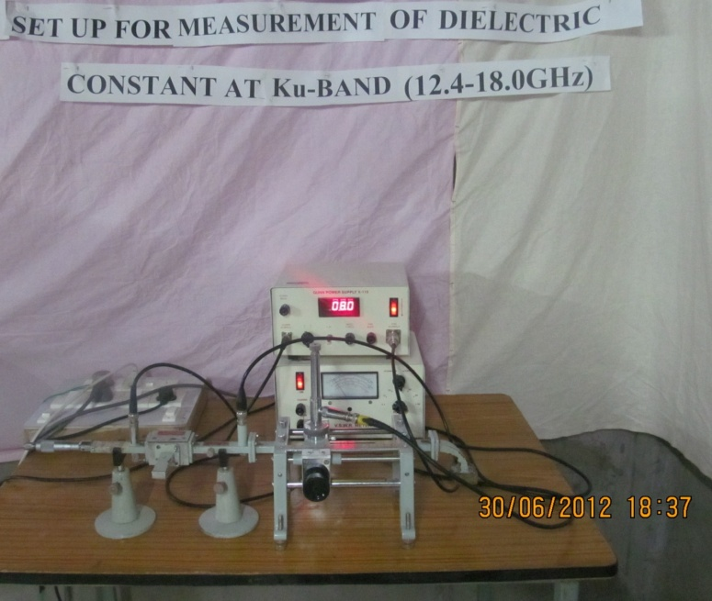
Fig. 3.5 Bench setup for measuring dielectric constant at 13.00 GHz
For frequency 13.00 GHz measurements taken for different forms of cereals are given as follows-
SAMPLES | DIELECTRIC CONSTANT | LOSS FACTOR
PRELIMINARY
Wheat | 3.4142 | 0.1591
Rice | 3.4947 | 0.0803
Arhar | 3.4331 | 0.1845
Chana | 3.4903 | 0.6726
Moong | 3.3279 | 0.2601
OVEN DRIED
Wheat | 3.1056 | 0.5956
Rice | 3.2350 | 0.8070
Arhar | 3.0165 | 0.6982
Chana | 3.0768 | 0.2166
Moong | 3.0527 | 0.3830
SATURATED
Wheat | 7.2644 | 2.3702
Rice | 7.1625 | 2.3353
Arhar | 6.5630 | 1.8566
Chana | 7.1360 | 2.2803
Moong | 6.6974 | 2.0410

Table 3.6 Tabulated form of Dielectric constants of cereals for Ku band

CHAPTER 4
OVERVIEW

4.1 COMBINATIONAL STUDY OF CEREALS
In order to determine the variability of dielectric constant with frequency, the measurements were made at different frequencies. The measurements have been made at four frequencies in the range 5 to 13 GHz. the values of dielectric constant of different samples are given in table -1,table - 2, table -3 and presented in figure 1,figure 2 ,figure 3,of preliminary samples , oven dried samples and saturated samples respectively.

4.1.1 RESULTANT MEASUREMENTS AND CURVES FOR CEREAL'S DIELECTRIC CONSTANT

Frequencies/samples | Wheat | Rice | Arhar | Chana | Moong
5.30 GHz | 9.037 | 8.7754 | 8.6727 | 8.4098 | 8.8048
6.60 GHz | 8.8451 | 8.5023 | 8.4805 | 8.2315 | 8.5509
10.65 GHz | 6.6643 | 6.6402 | 6.8166 | 6.4729 | 6.3555
13.00 GHz | 3.4142 | 3.4947 | 3.4331 | 3.4903 | 3.3279
Table 4.1 Values of dielectric constant for preliminary sample
Fig 4.1 variation of dielectric constant for different values of preliminary samples

Frequencies/Samples | Wheat | Rice | Arhar | Chana | Moong
5.30 GHz | 0.1591 | 0.1803 | 0.0591 | 0.1625 | 0.2601
6.60 GHz | 0.5056 | 1.2351 | 0.786 | 0.7469 | 1.2365
10.65 GHz | 0.7156 | 1.6594 | 1.2361 | 1.0591 | 1.2907
13.00 GHz | 1.9533 | 1.9603 | 1.9997 | 1.7403 | 1.9389
Table 4.2 Values of Loss Factor for preliminary sample

Fig 4.2 Variation of Loss Factor for different values of preliminary samples

Frequencies/samples | Wheat | Rice | Arhar | Chana | Moong
5.30 GHz | 8.8458 | 8.2015 | 8.1903 | 8.0805 | 8.4429
6.60 GHz | 8.6450 | 8.0509 | 8.0010 | 7.9998 | 8.0521
10.65 GHz | 6.2392 | 6.0010 | 6.5158 | 6.0264 | 6.0853
13.00 GHz | 3.1056 | 3.2350 | 3.0165 | 3.0768 | 3.0527

Table 4.3 values of dielectric constant for oven dried samples

Fig 4.3 variation of dielectric constant for different values of oven dried samples
Frequencies/samples | Wheat | Rice | Arhar | Chana | Moong
5.30GHz | 0.1527 | 0.1724 | 0.0358 | 0.1166 | 0.2376
6.60Ghz | 0.4132 | 1.0614 | 0.1845 | 0.6726 | 0.383
10.65GHz | 0.5077 | 1.2879 | 0.9827 | 0.8461 | 0.5021
13.00GHz | 0.8423 | 1.6718 | 1.5508 | 1.6259 | 1.1755

Table 4.4 values of Loss Factor for oven dried samples
Fig 4.4 variation of Loss Factor for different values of oven dried samples

Frequencies/samples | Wheat | Rice | Arhar | Chana | Moong
5.30 GHz | 11.0423 | 11.0012 | 10.8084 | 11.2015 | 10.7458
6.60 GHz | 10.8264 | 10.7765 | 10.2128 | 11.0519 | 10.5023
10.30 GHz | 8.5065 | 8.2617 | 7.2047 | 7.8613 | 7.4480
13.00 GHz | 7.2644 | 7.1625 | 6.5630 | 7.1360 | 6.6974

Table 4.5 values of dielectric constant for saturated sample
Fig 4.5 Variation of dielectric constant for different values of saturated samples

Frequencies/samples | Wheat | Rice | Arhar | Chana | Moong
5.30 GHz | 2.0152 | 1.9573 | 1.6955 | 1.5868 | 1.7532
6.60 GHz | 2.3702 | 2.3353 | 1.8566 | 2.2803 | 2.041
10.65 GHz | 3.4927 | 3.1592 | 2.3152 | 3.0519 | 2.2015
13.00 GHz | 3.5736 | 3.243 | 2.6051 | 3.5625 | 2.6927

Table 4.6 values of Loss Factor for saturated sample
Fig 4.6 Variation of Loss Factor for different values of saturated samples

It is observed from the above tables and figures that dielectric constant of five samples is different due to the difference in their physical properties. The data have been obtained by taking ten sets of readings for each sample and each set comprising of three values of the shift in minima obtained throughout the length of the slotted waveguide. In all, thirty readings were taken for each sample for each frequency. The process is repeated in order to check the accuracy and precision of microwave system used. The sets of readings were taken for four different frequency mentioned in table 1, table 2 and table 3. It was observed that there is slight variation in the value of dielectric constant with the increase in frequency, as is cleared from fig 1, fig 2 and fig 3.

4.1.2 VARIATION IN MOISTURE CONTENT WITH FREQUENCY AND DIELECTRIC CONSTANT

The variability in dielectric constant can be attributed to the presence of moisture in the samples, which they absorb when kept exposed to the atmosphere.

Frequencies/samples | Wheat | Rice | Arhar | Chana | Moong
5.30 GHz | 11.0423 | 11.0012 | 10.8084 | 11.2015 | 10.7458
6.60 GHz | 10.8264 | 10.7765 | 10.2128 | 11.0519 | 10.5023
10.65 GHz | 8.5065 | 8.2617 | 7.2047 | 7.8613 | 7.448
13.00 GHz | 7.2644 | 7.1625 | 6.563 | 7.136 | 6.6974

Table 4.7 values of dielectric constant for 30% moisture content
Fig 4.7 Variation of dielectric constant of different samples for different frequencies for 30%moisture content
Frequencies/samples | Wheat | Rice | Arhar | Chana | Moong
5.30 GHz | 2.0152 | 1.9573 | 1.6955 | 1.5868 | 1.7532
6.60 GHz | 2.3702 | 2.3353 | 1.8566 | 2.2803 | 2.041
10.65 GHz | 3.4927 | 3.1593 | 2.3152 | 3.0519 | 2.2015
13.00 GHz | 3.5736 | 3.243 | 2.6051 | 3.5625 | 2.6927

Table 4.8 values of dielectric constant for 30% moisture content
Fig 4.8 Variation of Loss Factor of different samples for different frequencies for 30%moisture content
Frequencies/samples | Wheat | Rice | Arhar | Chana | Moong
5.30 GHz | 10.9652 | 10.862 | 10.2102 | 10.552 | 10.0462
6.60 GHz | 10.5537 | 10.3096 | 10.044 | 10.5118 | 9.9745
10.65 GHz | 7.2349 | 7.5113 | 7.0988 | 7.7321 | 7.341
13.00 GHz | 6.9523 | 6.0729 | 5.3215 | 6.7695 | 5.4407

Table 4.9 values of dielectric constant for 20% moisture content
Fig 4.9 variation of dielectric constant of different samples for different frequencies for 20% moisture content
Frequencies/Samples | Wheat | Rice | Arhar | Chana | Moong
5.30 GHz | 1.7851 | 1.6123 | 1.5103 | 1.1961 | 1.3577
6.60 GHz | 1.9614 | 2.0115 | 1.6679 | 2.0573 | 1.9764
10.65 GHz | 2.9903 | 2.9621 | 2.0915 | 2.6214 | 2.3551
13.00 GHz | 3.1287 | 3.0488 | 2.2209 | 2.8941 | 2.8201

Table 4.10 values of Loss Factor for 20% moisture content

Fig 4.10 variation of Loss Factor of different samples for different frequencies for 20% moisture content

Frequencies/samples | Wheat | Rice | Arhar | Chana | Moong
5.30 GHz | 10.1261 | 9.8401 | 9.8815 | 9.9625 | 9.8091
6.60 GHz | 10.0115 | 9.9737 | 9.7513 | 9.988 | 9.5967
10.65 GHz | 7.02804 | 7.1579 | 6.8751 | 7.2216 | 6.9611
13.00 GHz | 5.0215 | 5.162 | 4.6231 | 6.2963 | 4.5621

Table 4.11 values of dielectric constant for 10% moisture content
Fig 4.11 variation of dielectric constant of different samples for different frequencies for 10% content
Frequencies/Samples | Wheat | Rice | Arhar | Chana | Moong
5.30 GHz | 1.2613 | 1.2305 | 1.0325 | 0.8462 | 1.1985
6.60 GHz | 1.465 | 1.8644 | 1.1213 | 1.8154 | 1.5028
10.65 GHz | 2.0321 | 2.1156 | 1.8854 | 2.1392 | 1.8816
13.00 GHz | 2.642 | 2.2946 | 2.0512 | 2.6031 | 2.1078

Table 4.12 values of loss Factor for 10% moisture content
Fig 4.12 variation of Loss factor of different samples for different frequencies for 10% content
Frequencies/samples | Wheat | Rice | Arhar | Chana | Moong
5.30 GHz | 9.8105 | 9.1456 | 9.5325 | 9.5119 | 9.0552
6.6 GHz | 9.862 | 8.9872 | 9.3705 | 9.4492 | 8.8903
10.65 GHz | 7.9403 | 6.8216 | 6.4856 | 6.831 | 6.3457
13.00 GHz | 4.9619 | 4.5009 | 4.5698 | 5.6257 | 4.0057
Table 4.13 values of different constants for 5% moisture content
Fig 4.13 variation of dielectric constant for different samples of different frequencies for 5% moisture content
Frequencies/Samples | Wheat | Rice | Arhar | Chana | Moong
5.30 GHz | 0.6933 | 0.9156 | 0.5213 | 9.5119 | 9.0552
6.6 GHz | 0.9523 | 1.5319 | 0.7428 | 9.4492 | 8.8903
10.65 GHz | 1.8406 | 1.7553 | 1.4261 | 6.831 | 6.3457
13.00 GHz | 1.6231 | 1.8932 | 1.9418 | 5.6257 | 4.0057
Table 4.14 values of Loss Factor for 5% moisture content
Fig 4.14 variation of Loss Factor for different samples of different frequencies for 5% moisture content

Fig 4.15 variation of dielectric constant for different samples of different frequencies for 2% moisture content
Frequencies/Samples | Wheat | Rice | Arhar | Chana | Moong
5.30 GHz | 9.0255 | 8.9112 | 9.0856 | 8.9456 | 8.9196
6.60 GHz | 9.0255 | 8.8562 | 8.2975 | 8.3864 | 8.3203
10.65 GHz | 6.4713 | 6.1925 | 6.0111 | 6.3419 | 6.1928
13.0 GHz | 4.1477 | 4.0502 | 3.9826 | 4.8206 | 3.9905

Table 4.15 values of dielectric constants for 2%moisture content
Frequencies/Samples | Wheat | Rice | Arhar | Chana | Moong
5.30 GHz | 0.2832 | 0.2059 | 0.2856 | 0.3251 | .5194
6.60 GHz | 0.5017 | 1.2886 | 0.3012 | 0.8305 | .5298
10.65 GHz | 1.0521 | 1.4125 | 1.0196 | 1.1924 | .6128
13.00 GHz | 1.1589 | 1.6319 | 1.4512 | 1.8119 | .9630

Table 4.16 values of Loss Factor for 2%moisture content
Fig 4.16 variation of Loss Factor for different samples of different frequencies for 2% moisture content
Though all these tables (table-4, table-5, table-6) and figures (fig 4, fig 5, fig 6) we observed that the value of ε’ is increases with the increase in moisture content. This is due to the presence of free water molecules in the sample. The water has dielectric constant of 80 at around 1 GHz and it decreases with frequency and also the dielectric constant changes when impurities are present in the water.

For moisture content we just add water in the samples ().the dielectric constants of the samples were measured after determining the weight of the sample before the measurement. Some measurements were also made before the settlement and just after adding water to cereals at the saturated limit of water-cereals mixture.
In the present study, the measurements were made for the preliminary samples, oven dried sample and sample having moisture content 2%, 5%, 10%, 20%, 30%.The results of measurements of moisture content of 2% to 12.00% have been reported in this properly.

Dielectric constant changes with humidity or water with water content, so that special arrangements have to be made to hold humidity constant and to determine its value or we can do it naturally just by drying it in air as shown in graphs below in fig-9,fig-10,fig-11,fig-12,fig-13and values refers according to table-11,table-12,table-13,table-14,table-14.
Grain moisture content is expressed as a percentage of moisture based on wet weight (wet basis) or dry matter (dry basis). Wet basis moisture content is generally used. Dry basis is used primarily in research.
M_{w} (wet basis) = $\frac{w-d}{w}$x (100)

M_{d} (dry basis) = $\frac{w-d}{d}$x (100)
Where,
w = wet weight
d = dry weight
M = moisture content on a percent basis

A representative sample must be obtained to provide a useful moisture content evaluation. Also, the moisture content of the product must be maintained from the time the sample is obtained until the determination is made by storing in a sealed container.

4.2 CONCLUSION
The moisture content can be determined by an oven method, which is a direct method. The grain is weighed and dried, then weighed again according to standardized procedures. The moisture content is calculated using the moisture content equations. Most moisture meters measure the electrical properties of grain, which change with the moisture content. This is considered an indirect method and must be calibrated by a direct method. It is important to follow moisture meter directions carefully to achieve an accurate moisture test. A moisture meter should be periodically checked to see if it is accurate. One method of checking the meter is to compare it to at least two other meters.
Moisture content/frequencies | 5.30 GHz | 6.60 GHz | 10.65 GHz | 13.30 GHz
2% | 9.0255 | 9.0255 | 6.4713 | 4.1477
5% | 9.8105 | 9.862 | 6.6902 | 4.9613
10% | 10.1265 | 10.115 | 7.02804 | 5.0215
20% | 10.9652 | 10.5537 | 7.9403 | 6.9523
30% | 11.0423 | 10.8264 | 8.5065 | 7.2644

Table 4.17 values of dielectric constant of wheat for different frequencies at different moisture content
Fig 4.17 variation of dielectric constant of wheat at different moisture content

Moisture content/frequencies | 5.30 GHz | 6.60 GHz | 10.65 GHz | 13.00 GHz
2% | 8.911 | 8.8562 | 6.1925 | 4.0502
5% | 9.1456 | 8.9872 | 6.8216 | 4.5009
10% | 9.8401 | 9.794 | 7.1579 | 5.162
20% | 10.862 | 10.3096 | 7.5113 | 6.0729
30% | 11.0012 | 10.7765 | 8.0194 | 7.1625

Table 4.18 values of dielectric constant of rice for different frequencies at different moisture content
Fig 4.18 variation of dielectric constant of rice at different moisture content
Moisture content/frequencies | 5.30 GHz | 6.60 GHz | 10.65 GHz | 13.0 GHz
2% | 9.0856 | 8.297 | 6.0111 | 3.9826
5% | 9.5325 | 9.3705 | 6.4856 | 4.5698
10% | 9.8815 | 9.7513 | 6.8751 | 4.6231
20% | 10.2102 | 10.044 | 7.0988 | 5.3215
30% | 10.8084 | 10.2128 | 7.2047 | 6.563

Table 4.19 values of dielectric constant of Arhar for different frequencies at different moisture content
Fig 4.19 variation of dielectric constant of Arhar at different moisture content
Moisture content/frequencies | 5.30 GHz | 6.60 GHz | 10.65 GHz | 13.00 GHz
2% | 8.8466 | 8.3864 | 6.3419 | 4.8206
5% | 9.5119 | 9.4492 | 6.831 | 4.6257
10% | 9.9625 | 9.958 | 7.2216 | 6.2963
20% | 10.552 | 10.5118 | 7.7321 | 6.7695
30% | 11.2015 | 11.0519 | 7.8613 | 7.136

Table 4.20 values of dielectric constant of chana for different frequencies at different moisture content
Fig 4.20 variation of dielectric constant of Chana at different moisture content

Moisture Content/frequencies | 5.30 GHz | 6.60 GHz | 10.63 GHz | 13.00 GHz
2% | 8.9196 | 8.3203 | 6.1928 | 3.9905
5% | 9.0552 | 8.8903 | 6.3457 | 4.0057
10% | 9.8091 | 9.5967 | 6.9611 | 4.5621
20% | 10.0462 | 9.9745 | 7.341 | 5.4407
30% | 10.7458 | 10.5023 | 7.448 | 6.6974

Table 4.21 values of dielectric constant of Moong for different frequencies at different moisture content
Fig 4.21 variation of dielectric constant of Moong at different moisture content

CONCLUSION

In this report the direction in which the project has moved has been indicated where we estimated the dielectric constant of various cereals using the theoretical models and then compare it with the practical values of dielectric constants of same cereals obtained through the radiometer.

This report also shows the behaviour of dielectric constant of cereals (wheat, rice, arhar, chana, moong) using theoretical model of two point method (wave guide method).

The dielectric constant is dependent of frequency and stays constant only over relatively small portions of the frequency spectrum .But , the variation of ε’ with frequency is sufficiently gradual that it can considered to be constant over a fairly wide frequency band for most common microwave applications. The percentage variation in Є” is almost always greater than that of ε’, so that ε” should be measured near the frequency or frequencies of interest. In some cases, ε_{r} is affected by temperature, so that the temperature should be held constant.

The method for the complex permittivity of cereals has been developed, by maintaining relationships of theoretical and physical significance. The estimated permittivities and loss factors of rice, wheat, moong dal, chana dal, Arhar dal with average accuracies of 5 % to 10 % over the frequencies 5.30 GHz, 6.60 GHz, 10.63 GHz, 13.00 GHz and moisture content range from 2% to 30 %, wet basis.

REFERENCES

[1].W. Stephen Cheung, Frederic H. Levine, Microwave Made Simple: Principles and Applications (1985)

[2]. Calla O P N, Defense Research & Development Organization, Microwave Remote Sensing (2009)

[3]. Calla O P N, Vivek Ranjan, Chetan Bohra, Gangadhar L Naik, National institute of Technology, Hazarthbal,17(2004).

[4]. Calla O P N, S Agarwal, S K Agarwalla, R Bhattacharjee& A Kalita, Assam Engineering College,Guwahati,20(2002).

[5]. Yashwant Sharma, LET US SEE (C Language)

ANNEXURE
C program for estimating complex dielectric constant from theoretical model two minima method.
Program 1
#include<stdio.h>
#include<conio.h>
#include<math.h>
void main()
{
float G,D,Dr,r,L,k,K,Z,P,a,b,A,x,H,Ge,Be,c,R,K1,d,E1,E2;
clrscr();
printf("enter the values G,D,Dr,r,L");
scanf("%f%f%f%f%f",&G,&D,&Dr,&r,&L);
k=(2*3.14)/(G);
printf("k=%f\n",k);
Z=2*k*(D-Dr-L);
a=sin((Z*3.14)/180);
b=cos((Z*3.14)/180);
P=(r-1)/(r+1);
K=(-2*P*a)/(k*L*(1+pow(P,2)+2*P*b));
printf("Z=%f\nP=%f\nK=%f",Z,P,K);
A=(pow(P,2)-1)/(k*L*(1+pow(P,2)+2*P*b));
printf("enter d values x,H");
scanf("%f%f",&x,&H);
R=(A*pow(x,2))/(H-(x)*(1+pow(H,2)));
printf("A=%f\nR=%f",A,R);
printf("enter value of Ge,Be,c");
scanf("%f%f%f",&Ge,&Be,&c);
d=tanh((R*3.14)/180);
K1=(R*d*(1+pow(H,2))+(x*H*(1-pow(d,2))))/((pow(R,2)+pow(x,2))*(1+pow(d,2)*pow(H,2)));
E1=(Ge+pow((G/(2*c)),2))/(1+pow((G/(2*c)),2));
E2=(-1*(Be/(1+pow((G/(2*c)),2))));
printf("\nA=%f\nR=%f\nK1=%f\nE1=%f\nE2=%f",A,R,K1,E1,E2);
getch();
}

program 2
#include<math.h>
main()
{
float T,X,R,J,Q,k,l,Ge,Be,E1,E2,G,c;
clrscr();
printf("enter d values X,R,k,l,J,G,c");
scanf("%f%f%f%f%f%f%f",&X,&R,&k,&l,&J,&G,&c);
T=sqrt(pow(X,2)+pow(R,2));
Q=2*(J-90);
Ge=pow((T/(k*l)),2)*cos((Q*3.14)/180);
Be=pow((T/(k*l)),2)*sin((Q*3.14)/180);
printf("the values are");
printf("%f\n%f",Ge,Be);
E1=(Ge+pow((G/(2*c)),2))/(1+pow((G/(2*c)),2));
E2=(-1*(Be/(1+pow((G/(2*c)),2))));
printf("%f\n%f",E1,E2);
getch();
}

CONSTANTS AND VARIABLES LISTED IN PROGRAM STANDS FOR:
G=λ_{g}=Waveguide Wavelength
D=Sample Minima Position
D_{r}=Short Circuit Minima Position
r=VSWR=Voltage Standing Wave Ratio
L=l_{e}=Length of Sample
k=Propagation Constant
Z=φ=phase Pattern (Angle)
P=ϼ=Reflection Coefficient
K=Constant
H=tan x, x=Constant
A=Constant
K1=K'=Constant
R=Constant
G_{e}=Real Part of Admittance
B_{e}=Imaginary Part of Admittance
c=a=Waveguide width (Broader side)
E1=є'=Storage Factor (Dielectric Constant)
E2=є"=Loss Factor

